NWTEMC Monthly Meeting
MINUTES
February 19th, 2009 10:00 AM
Lummi Indian Reservation
Silver Reef Casino, 4884 Haxton Way, Ferndale Washington 98248

Attendees (sorted by Tribe/Agency):

Sheryl Lowe | American Indian Health Commission of WA | slowe@aihc-wa.org
Wes Seyler Jr. | Colville Tribes | Wes.seyler@colvilletribes.com
Del Ostenberg | Colville Tribes | Del.ostenberg@colvilletribes.com
Steve Debow | CSEPP, WA EMD | s.debow@emd.wa.gov
Max Rice | FEMA Tribal | max.rice@dhs.gov
TJ Harmon | Island Red Cross | harmont@islandredcross.org
Gary James | Lummi Nation Police | garyj@lummi.nsn.gov
Jim L. Fernando | Nooksack Tribal Police | jfernando@nooksack-tribe.org
Glenn Yorks | Nooksack Tribe | gyorks@nooksack-nsn.gov
Glenn Coil | NWTEMC | glenn@nwtemc.org
Lynda Harvey | NWTEMC | Lynda@nwtemc.org
Shari Mattson-Cooper | NWTEMC/MRC | Scooper.mattsoncooper@gmail.com
John Zingg | Red Cross | johnzingg@gmail.com
Katie Denter | Region 1 Public Health | kdenter@shd.snohomish.wa.gov
Keith Tucker MD | Samish Tribe | ktucker@samishtribe.nsn.us
Lee Shipman | ShoalwaterBay Tribe | leshipman@shoalwaterbay-nsn.gov
Richard Zambrano | Snoqualmie Tribe | Richard@snoqualmienation.com
Claude Cox | Spokane Tribe | claudec@spokanetribe.com
Jim Sande | Swinomish Tribe | jsande@swinomish.nsn.us
Rochelle James | Tulalip Tribes OEM | rochellejames@tulaliptribalpolice.org
Joe Hemmerich | Upper Skagit Tribe | joeh@upperskagit.com
Maria Gardipee | WA DOH, Tribal Liaison | Maria.gardipee@doh.wa.gov
Marge Edwards | WA EMD | m.edwards@emd.wa.gov
Max Messman | WA EMD | m.messman@emd.wa.gov
Agenda Items

Attachments:
Conflict of Interest Policy with legal comments
Conflict of Interest Policy update incorporating legal comments
Minutes Nov. 2008 NWTEMC meeting
Minutes Jan. 2008 NWTEMC meeting
Kalispel Tribe Red Cross DAT powerpoint
GETS/WPS phone service flyer
Tribal CERT/Emergency Prep Proposal, DOH
- Introductions
- Review and Adoption of November 2008, January 2009 Meeting Minutes
- Disaster Declaration Update
- John Zingg, Spokane Chapter, American Red Cross: Kalispel Tribal Disaster Action Team
- NWTEMC Incorporation & Non-profit status update
  - Adoption of Conflict of Interest Policy
  - Financial Report
  - NWTEMC Grant monies : MRC and Homeland Security
  - CERT Trailer
- Website Update
- Current Grants
  - FY 2008 IECGP Grant
  - Tribal Supplement: State Homeland Security Grant
- Upcoming Grants
  - FY 2009 IECGP
  - Tulalip Casino Grant for CERT Training & Equipment
  - WA DOH CERT Grant
- Creation of an Interoperability Communications Sub-committee
- Tribal Representatives to FEMA Pre-disaster mitigation grant review panel in DC February 2009
- Upcoming Conferences, Trainings, Events
- NWTEMC Annual Conference
- Tribal Representative on WA State Emergency Response Commission (SERC)
- GETS, WPS: Emergency Phone Services
- New Business
- Good of the Order

Meeting Minutes:
Meeting came to order about 10:15 am. Lee Shipman, NWTEMC of the Shoalwater Bay Tribe gave the opening prayer.
10 of 18 voting member tribes present
Introductions
Introductions were made by all Tribal representatives from member Tribes and by representatives from partner agencies: FEMA, EMD, American Indian Health Commission, Red Cross (Spokane and Island Chapters) and Region 1 Public Health.
Review and Adoption of November 2008, January 2009 Meeting Minutes
Motion: adopt Nov 2008, Jan 2009 NWTEMC Meeting Minutes
Seconded
Vote: 10 for 0 against
APPROVED
Disaster Declaration Update
John Zingg, Spokane Chapter, American Red Cross: Kalispel Tribal Disaster Action Team
Tribal Representative on WA State Emergency Response Commission (SERC)
NWTEMC Incorporation & Non-profit status update
Adoption of Conflict of Interest Policy
Discussion: An adopted Conflict of Interest Policy is necessary for NWTEMC’s IRS non-profit status. At last meeting Council requested staff to have legal review of drafted policy. Andrea from Snoqualmie Tribe Legal reviewed policy and made only minor comments related to terminology and definitions which were incorporated Policy.
Motion: adopt NWTEMC Conflict of Interest Policy
Seconded,
Vote: 10 for, 0 against.
APPROVED
Financial Report
Fuzzy Fletcher, NWTEMC Treasurer, could not make meeting this month so staff reported that a draft financial report has been prepared and Official Report will be submitted at next NWTEMC meeting in March.
NWTEMC Grant monies : MRC and Homeland Security
Status quo
CERT Trailer
NWTEMC and Tulalip Tribes are proud to announce that the legal issues have been resolved and that the Regional CERT Training Trailer has been transferred to the NWTEMC. NWTEMC is in process of transferring title, registration.
Website Update
Glenn reported no major updates to website. It was reported that all disaster declaration information is posted on the website on the disaster events page:
http://www.nwtemc.org/events.aspx
Current Grants
FY 2008 IECGP Grant
Tribal Supplement: State Homeland Security Grant
Upcoming Grants
FY 2009 IECGP
Tulalip Casino Grant for CERT Training & Equipment
Pre-approved, NWTEMC needs non-profit status letter from IRS
WA DOH CERT Grant
Creation of an Interoperability Communications Sub-committee
Discussion
Motion: Create an Interoperability Communications sub-committee of the NWTEMC.
Seconded
Vote: 10 for 0 against
APPROVED

Tribal Representatives to FEMA Pre-disaster mitigation grant review panel in DC February 2009
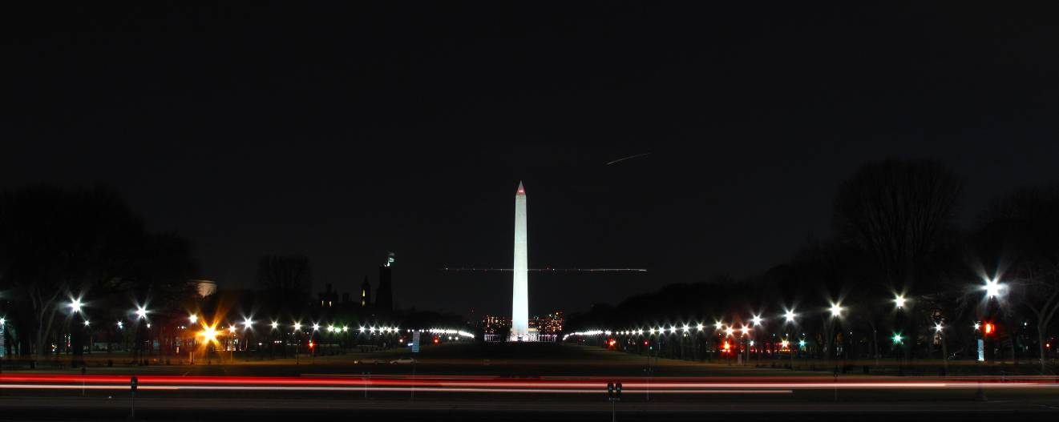
photo by glenn 2.11.2009
Upcoming Conferences, Trainings, Events
NWTEMC Annual Conference
Need to coordinate with other conferences: NPAIHB, WASPC, WSEMA so dates do not conflict.
Sept 15, 16th agreed as tentative dates (That’s a Tuesday and Wednesday)
Coeur d’Alene chosen as preferred location and staff will check to seeing if Coeur d’Alene Tribe is willing to host the 2009 NWTEMC Conference.
Tribal Representative on WA State Emergency Response Commission (SERC)
GETS, WPS: Emergency Phone Services
New Business
Good of the Order

