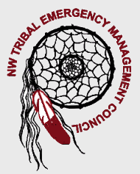


Region I Homeland Security
Tribal Committee
www.nwtemc.org

February 21, 2008
10:00 AM-1:00 PM
Location is at the Tulalip Casino, Cabaret Room, Quilceda, WA 98271
********************************************************************************************
Meeting Called By: Lynda Harvey, Chairperson NWTEMC
Introductions
Agenda Topics:

- WA Tsunami Representatives
  - George Crawford and Dave Nelson

- Elections Announcements
  - Chair/Vice Chair/Secretary

- Recruitment of Additional Members

- Conference Calling- Chief Budrow

- Legislation Update

- State Emergency Response Commission: January 25th, 2008 Meeting

- DOH Grants/EMPG Grants/Emergency Fuel

- Web Site Updates

- Hospital/ Statewide EOC

- Training Opportunities

