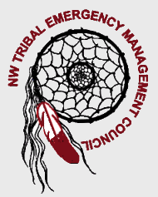


Region I Homeland Security
Tribal Committee
www.nwtemc.org

March 20th, 2008
10:00 AM-1:00 PM
Location is at the Tulalip South Lot, STARS Room, Tulalip, WA 98271
********************************************************************************************
Meeting Called By: Lynda Harvey, Chairperson NWTEMC
Introductions
Agenda Topics:

- State Emergency Response Commission: January 25th, 2008 Meeting

- Recruitment of Additional Members: Muckleshoot Tribe

- Mary Schoenfeldt – White House Committee: Children & Preparedness

- ICTAP – Ilene Hollingshead & Steve McLaughlin

- Casino Preparedness – Fuzzy Fletcher

- NW Indian College Update

- Free Haz-Mat E-581

- Hot Topics: NW Center for Healthcare Practice

- Medical Reserve Corps & AmericaCorps Vista Workers

- Grants:
  - EMPG Grant
  - Homeland Security Direct
  - UASI Grant
- Web Site Updates: Grants Page

- Ham Radio/RACES licenses:
  - Lynda Harvey – KE7RWG
  - John Harvey - KE7RWF
  - Glenn Coil - KE7RWE

- IAEM – Call for members to ask Senators to increase EMPG funding

- NWTEMC Annual Conference

