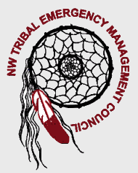


Region I Homeland Security
Tribal Committee
www.nwtemc.org

June 19th, 2008
10:00 AM-1:00 PM
Location is at the Tulalip Emergency Mgmt. Office, Tulalip, WA 98271
********************************************************************************************
Meeting Called By: Lynda Harvey, Chairperson NWTEMC
Introductions:
Shanon Hamilton, Muckleshoot Tribe
Agenda Topics:

- NWWarn

- Medical Reserve Corps & AmericaCorps Vista Workers

- Grants:
  - EMPG Grant
  - Homeland Security Direct
  - UASI Grant
  - EOC Grant

- Web Site Updates: Grants Page, 2008 NWTEMC Conf.

- NWTEMC Annual Conference Sept 16-17, 2008, Great Wolf Lodge

- Smart PH

- I-link webinar

- ICTAP – Bill Ekse

