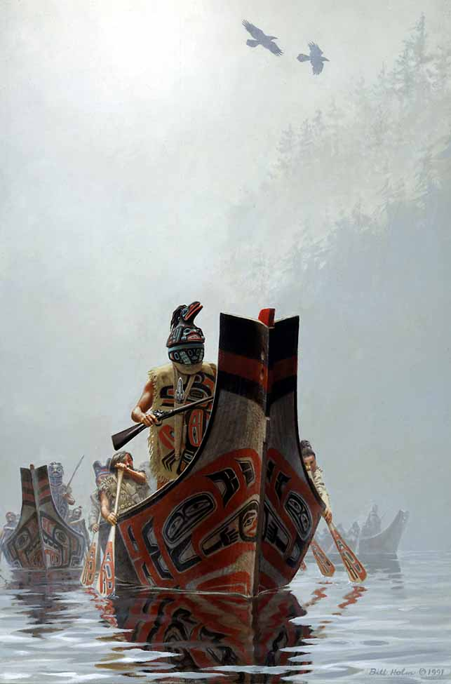

Region I Homeland Security Tribal Committee
MINUTES

09/20/2007
10:00 AM-1:00 PM
Location: Upper Skagit Cultural Resources Building
********************************************************************************************
NWTEMC meeting | SIGN-IN
Glenn Coil | Tulalip | 360.5651.3294
Paul D. Budrow | Upper Skagit PD | 360.661.1544
Jim Fernando | Nooksack Tribe PD | 360.592.9065
Joe Hemmerich | Upper Skagit | 360.854.7045
Paula Lurf | Upper Skagit | 360.854.7020
Roberta Losik-Welch | MRC | 425,343.5130
Lynda Harvey | Tulalip PD | 360.651.3295
AGENDA Topics:
MINUTES:

