Tulalip Tribes

Medical Reserve Corps

Volunteer Handbook

NOTES

Welcome

Dear Medical Reserve Corps Volunteer,

On behalf of the Medical Reserve Corps, welcome and thank you for joining our volunteer team.

Hundreds of volunteers donated their time and talents last year to help local citizens in major emergencies and/or disasters. We continue to need volunteers to accomplish all of our goals. Thank you so much for making the Medical Reserve Corps part of your volunteer activities.

This handbook was created to give you pertinent information that will maximize your volunteer experience. Please take the time to read through it and refer back as questions arise. The orientation program also provides valuable information and will offer an opportunity to ask questions and meet other MRC volunteers.

Always feel free to call Tulalip Tribes Office of Emergency Management for additional information or to pass along suggestions or comments. Messages for the MRC volunteer coordinator can be left at (360) 651-3294.

Once again, welcome to the Tulalip Tribes Medical Reserve Corps!

Sincerely,

Lynda Harvey Roberta Losik-Welch

Lynda Harvey Roberta Losik-Welch
Director Unit Coordinator
Tulalip Tribes Tulalip Tribes MRC
Office of Emergency Management

Table of Contents

Welcome 2

Table of Contents 3

About this Handbook 4

History of Citizen Corps/Medical Reserve Corps 5

Tulalip Tribes Medical Reserve Corps 6

Background 7

Organizational Chart 9

General Information 10

Liability 13

Policies 15

Code of Conduct 18

Volunteer Rights & Responsibilities 20

Notes 21

Volunteer Time Log 22

Forms 24

About This Handbook

Your enrollment and orientation are important first steps to an exciting and complex organization, which offers a variety of opportunities to serve our community. The following pages describe the benefits to our volunteers, plus policies and procedures that provide a framework for the services we deliver.

The information in this handbook is extensive but not complete. Each position has policies and procedures specific to the function you will perform.

You will learn much of the information regarding your responsibilities on the job. If you have any questions along the way, contact us at 360-651-3294.

Please take the time to read this handbook carefully. Then, keep it as a reference source to use when you have questions or concerns.

We wish you a rewarding experience as a Medical Reserve Corps volunteer.

History of Citizen Corps/Medical Reserve Corps

Uniting Communities - Preparing the Nation
In his 2002 State of the Union Message, President Bush called on all Americans to make a lifetime commitment to serve their communities, the nation and the world. President Bush announced the creation of USA Freedom Corps to help Americans answer his call to service and to foster a culture of service, citizenship and responsibility.

The Citizen Corps is the component of USA Freedom Corps that creates local opportunities for individuals to volunteer to help their communities prepare for and respond to emergencies.

The Medical Reserve Corps is the component of the Citizen Corps that will bring together local health professionals and others with relevant health related skills to volunteer in their community. They will assist local, existing community emergency medical response systems as well as provide a group of readily trained and available resources to help our community deal with pressing public health needs and improvements.

Tulalip Tribes is one of the first tribal communities in the nation with an active Medical Reserve Corps.

Our partners throughout Snohomish County and Washington State have the common goal of helping the community prevent, prepare for and respond to crime, disasters, pressing public health needs and emergencies of all kinds.

Volunteers are the key to making our community a safer place to live. We look forward to working with you in this important community effort.

Tulalip Tribes Medical Reserve Corps

Mission of the Tulalip Tribes Medical Reserve Corps

The mission of the Tulalip Tribes Medical Reserve Corps (MRC) is to provide medical assistance to members of the Tulalip Community during times of emergency.
It also provides an opportunity for local medical and health professionals to contribute their skills and expertise throughout the year as well.
Our Medical Reserve Corps unit is made of medical and health volunteers who can assist our community during emergencies, such as an earthquake, influenza epidemic, a chemical spill, or an act of terrorism.

Benefits to the Community
Major local emergencies can overwhelm the capability of first responders, especially during the first 12-72 hours. Having citizens who are prepared to take care of themselves, their families and others during times of crisis will allow first-responders to focus their efforts on the most critical, life threatening situations.

An organized, well trained Medical Reserve Corps unit means that volunteers can effectively respond to an emergency, are familiar with their community’s response plan, know what materials are available for their use, know who their partners in the response are, and know where their skills can be utilized to their best advantage while responding in a coordinated manner.

An Organized Team Approach
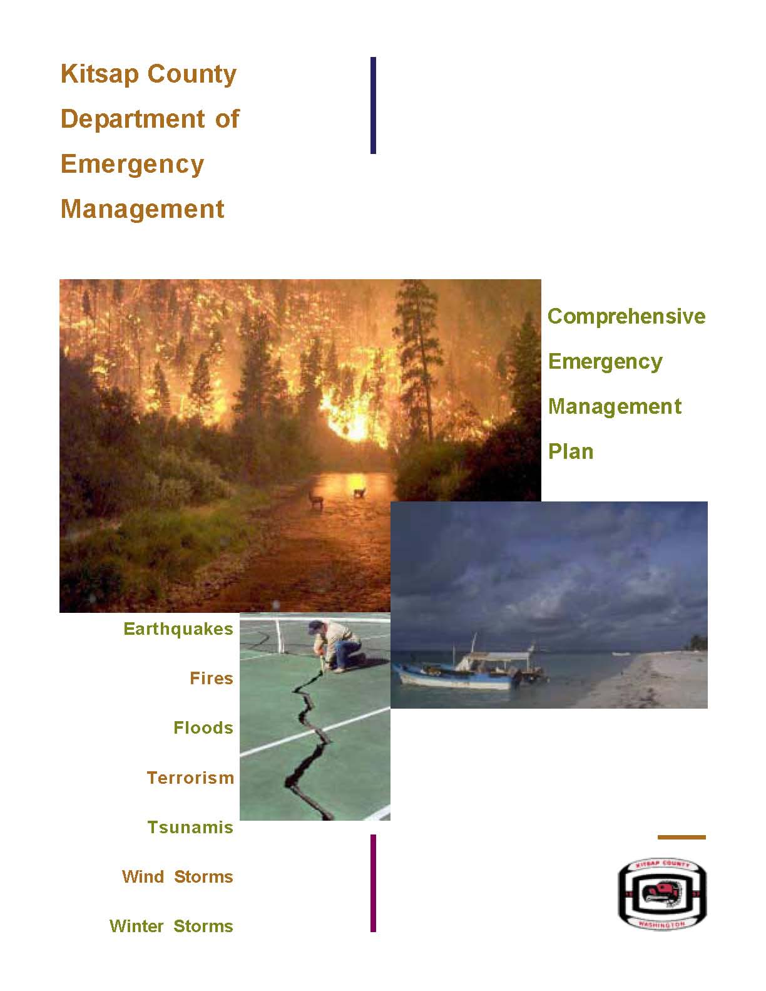
During an emergency, Tulalip Tribes will activate its Comprehensive Emergency Management Plan (CEMP). This plan defines how emergency personnel (fire, law enforcement, emergency medical services) will respond to and manage the emergency. Spontaneous volunteers may hinder rescue efforts because they may not be familiar with local plans or procedures.

By creating a Medical Reserve Corps unit that is linked to Tulalip Tribes’ CEMP, the members of the Medical Reserve Corps can truly benefit the community by knowing what their role is during an emergency, how they fit into the emergency plan, and how best to respond so that they are a positive support structure for the first responders.

Background

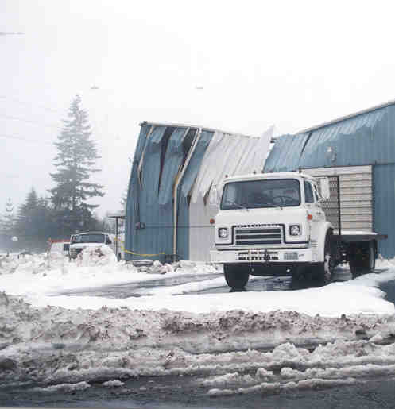
The Pacific Northwest has had an extensive history of disasters ranging from severe windstorms, flooding and winter storms. In recent years the Pacific Northwest experienced devastation caused by the to the 2001 Nisqually Earthquake, the 2006 Super Bowl Sunday Storm and the severe windstorms of December 2006 and January 2007. These natural disasters caused millions of dollars in damage to the region. Along with damage to the area, earthquakes and severe winter storms could quickly cause the Tulalip community to become isolated from Puget Sound metropolitan areas.

During past winter storms emergency medical response systems were critically taxed. Normal 4-to-5 minute response times stretched to an hour or more throughout the northwest because of the severe winds, ice and snow. Although many of the injuries were not immediately life-threatening, people in the farthest reaches of our community did not have access to or were unable to receive any type of medical treatment in the immediate aftermath of the disaster.

The attacks on September 11, 2001 further demonstrate how quickly our community becomes isolated not only from the Puget Sound metropolitan areas, but also from our community partners in preparedness, the military. On September 11th every military base in the world was dedicated to protect and prepare for additional terrorist attacks. Until the nation knew what would come next, this protective action meant we could not help each other as we do on a day-by-day basis. This included emergency medical services.

In response to any of these types of disasters, the Tulalip community should be prepared to help. The Tulalip Tribes MRC provides a system to develop and coordinate a response structure of medical volunteers in our community.

Tulalip Tribes Medical Reserve Corps will prepare by:

- Recruiting medical volunteers who are Tulalip Tribal members, employees and Tulalip community residents. Volunteers are recruited from various health disciplines and may include retirees, and active and retired military members.

- Partnering with the Tulalip Tribal Health Clinic, EMS and the public health community to better understand medical command and control procedures with pre-positioned sites for medical volunteers to establish and manage when requested through Emergency Support Function (ESF) 8 under the Tulalip Tribes’ Emergency Management Plan (CEMP).

- Pre-registering all medical volunteers as Washington State Emergency Workers (this registration may also take care of malpractice/liability issues).

- Develop an orientation, training and exercise program for volunteers.

- Recruiting other support personnel to MRC including RACES, CERT, security, records’ clerks, informational services, etc.

Results and Benefits Expected:


Recruitment for the Medical Reserve Corps (MRC) will be community based and volunteer managed. The recruitment process will not be limited to physicians and nurses. It will be inclusive of all medical professionals both licensed and those in administrative roles. The MRC will offer flexibility and allow volunteers to establish “volunteer time limits” which cannot be offered in other types of programs such as Disaster Medical Assistance Teams (DMAT). Tulalip Tribes MRC will be designed to use local health professionals within the community and will accommodate the volunteers’ schedules.

The Tulalip Tribes MRC will be incorporated into both the Tulalip Tribes’ Comprehensive Emergency Management Plan (CEMP) through Emergency Support Function (ESF) 8 and the Tulalip Tribes’ Emergency Operations Center Plan. All emergency and disaster related functions of the MRC will be initiated through ESF 8, and provide new volunteer opportunities within the public health system. The MRC will enhance and improve the emergency medical response capacity in the community. The program will enhance Tulalip Tribes’ ability to respond to either a natural hazard or a terrorism event and be the designated volunteer corps utilized to manage: public health emergencies, mass vaccination clinics, distribution of the strategic national pharmaceutical stockpile, plus the overflow treatment areas and field hospitals as needed in a terrorism event or disaster.

Safe, rapid and effective service will be available during a major emergency or disaster with:
Careful planning
Predetermined treatment sites
Pre-identified, certified, and trained volunteers.

The chart on the following page shows how the Medical Reserve Corps fits into the overall organizational structure of Tulalip Tribes.

Tulalip Tribes
ORGANIZATIONAL CHART

Tulalip Tribes
Board of Directors
General Manager

Direction

Tulalip Tribes
Office of Emergency Management

Coordination

Volunteer
Organizations

Medical
Reserve Corps

RACES

Neighborhood Watch

Block Watch

CERT Program

The Medical Reserve Corps will work under the direction of the Tulalip Tribes’ Department of Emergency Management’s Unified Command during a disaster.

The Tulalip Tribes’ Emergency Operations Center will activate the Medical Reserve Corps in times of disaster where necessary.

General Information

Volunteer Assignments
Volunteer applications and interviews will go through the MRC volunteer coordinator and Tulalip Tribes Department of Emergency Management.

The volunteer coordinator may assign volunteer positions in advance of emergencies and public health activities. Position descriptions will outline general and specific duties that you could be expected to perform. It may also outline the training required in order to carry out your assigned duties. MRC volunteers may be asked to report to a specific geographic location in an emergency.

The MRC unit will work closely with the Tulalip Tribes Emergency Manager, Tulalip Health Clinic Director, Fire Department and other emergency leaders because of their ongoing responsibilities and specific expertise.

Identification
The Department of Emergency Management will ensure that carefully controlled individual photo ID badges are prepared and issued to each volunteer.

Volunteer Safety
All volunteers will receive safety training that is appropriate to their function in the Medical Reserve Corps unit.

It is recommended that all volunteers have current immunizations, including tetanus, influenza, and hepatitis B.

Maintaining Readiness
Regular training exercises are an essential element for ensuring readiness.

Being ready to respond in an emergency does not just happen—readiness requires planning, organization and practice.

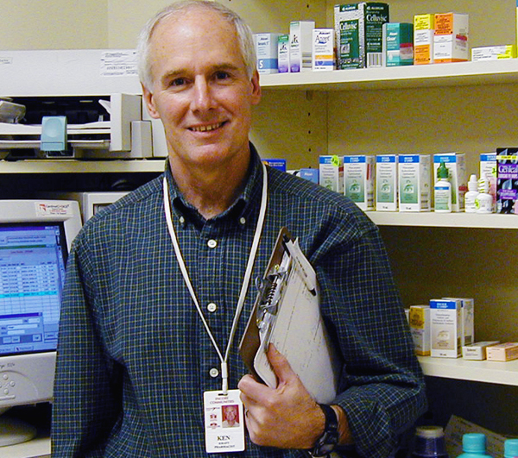
Tulalip Tribes Medical Reserve Corps will have regular meetings and drills to ensure maximum emergency preparedness.

All Medical Reserve Corps volunteers must have the appropriate education, training and experience. All members of the MRC unit do not need the same education and training, although there are some common elements.

The MRC unit will be trained and prepared to:
- Manage Neighborhood Distribution Centers (specified locations to support a mass vaccination strategy)
- Manage the distribution of the Strategic National Pharmaceutical Stockpile
- Work in overflow treatment areas and field hospitals as needed

Preparedness is each individual’s responsibility. Ensuring you are prepared at home and at work will allow you to be ready to respond when you are needed. The Tulalip Tribes Department of Emergency Management has free information that can help you prepare for all hazards.

Training
Medical Reserve Corps unit leaders will have a training checklist to ensure that volunteers who are registered can be documented on training they have had and/or need. All Medical Reserve Corps volunteer training must include:

- Medical Reserve Corps orientation
All registered volunteers are expected to participate in the Orientation course prior to starting as a volunteer. This program provides a broad overview of the various services and activities of the Medical Reserve Corps at the local & national level.
- Bloodborne Pathogens
- CPR/First Aid
- ICS/NIMS courses
Volunteers are required to complete ICS 100 and NIMS 700 classes. Both of these courses can be done online and the completion certificate sent to the volunteer coordinator. These can be accessed through the FEMA website.
IS-100 (Introduction to Incident Command)
IS-700 (National Incident Management System)
In-class training may also be available to volunteers, please check with the volunteer coordinator for a schedule.

Funding
Volunteer time is uncompensated.
Tulalip Tribes Department of Emergency Management and Snohomish County DEM and Health District are responsible for supplies and other support during a disaster, which may include:

- Education and training
- Protective equipment and clothing
- Supplies (gloves, syringes, splints, etc.)
- Food and shelter
- Communication equipment (2-way radios, ham radios etc.)

Our Emblem:

The Medical Reserve Corps is a recognized emblem that must be used in a standard form. There are guidelines that include color, placement, font and size. Uniform T-shirts or vests with this MRC logo may be issued to registered and credentialed MRC volunteers in order to be easily identified in the field.

Web Site
The National Medical Reserve Corps is on the web! Go to the web site at www.medicalreservecorps.gov. This site provides information on the national organization and individual units across the county.

The Tulalip Tribes Medical Reserve Corps is also on the web! Go to our web site at www.nwtemc.org and click on the MRC logo.

The NWTEMC site will keep you updated as to training schedules, events, etc. Your friends, colleagues, and family can apply to be volunteers by downloading our online application forms. Complete the form and return to the MRC volunteer coordinator or Tulalip Tribes Office of Emergency Management.

Newsletter
A quarterly newsletter will soon be accessible from the NWTEMC website at www.nwtemc.org.

If you do not have internet access, please let the MRC volunteer coordinator know and it will be sent to you. This newsletter will keep you up to date on what’s happening in our volunteer program, new volunteer opportunities, and upcoming events.

The skills and services of each Medical Reserve Corps worker are critical to our success and effectiveness. Volunteers and paid staff are colleagues who form a team united by shared goals and values. Like any team, the contributions of each member are unique and crucial. By serving on the Medical Reserve Corps team, volunteer staff earns certain benefits. These benefits are outlined in the following pages.

Liability

Insurance
A comprehensive liability insurance policy covers volunteers while working under the supervision and direction of the Department of Emergency Management. The MRC volunteers are insured against personal or bodily injury or property damage. For full disclosure, you can go online to http://access.wa.gov/, and click on “laws and rules”.

WAC 118-04-200
Personal responsibilities of emergency workers
(1) Emergency workers shall be responsible to certify to the authorized officials registering them and using their services that they are aware of and will comply with all applicable responsibilities and requirements set forth in these rules.
(a) Emergency workers have the responsibility to notify the on-scene authorized official if they have been using any medical prescription or other drug that has the potential to render them impaired, unfit, or unable to carry out their emergency assignment.
(b) Participation by emergency workers in any mission, training event, or other authorized activity while under the influence of or while using narcotics or any illegal controlled substance is prohibited.
(c) Participation by emergency workers in any mission, training event, or other authorized activity while under the influence of alcohol is prohibited.
(d) Emergency workers participating in any mission, training event, or other authorized activity shall possess a valid operator's license if they are assigned to operate vehicles, vessels, or aircraft during the mission unless specifically directed otherwise by an authorized official in accordance with RCW 38.52.180. All emergency workers driving vehicles to or from a mission must possess a valid driver's license and required insurance.
(e) Use of private vehicles, vessels, boats, or aircraft by emergency workers in any mission, training event, or other authorized activity without liability insurance required by chapter 46.29 RCW is prohibited unless specifically directed otherwise by an authorized official in accordance with RCW 38.52.180.
(f) Emergency workers shall adhere to all applicable traffic regulations during any mission, training event, or other authorized activity. This provision does not apply to individuals who have completed the emergency vehicle operator course or the emergency vehicle accident prevention course and who are duly authorized under state law to use special driving skills and equipment and who do so at the direction of an authorized official.

(2) Emergency workers have the responsibility to comply with all other requirements as determined by the authorized official using their services.
(3) When reporting to the scene, emergency workers have the responsibility to inform the on-scene authorized official whether they are mentally and physically fit for their assigned duties. Emergency workers reporting as not fit for currently assigned duties may request a less demanding assignment that is appropriate to their current capabilities.
(4) Emergency workers have the responsibility to check in with the appropriate on-scene official and to complete all required recordkeeping and reporting.

The Volunteer Protection Act
(“VPA”)(Codified at 42 U.S.C. § 14501 et. seq.) Provides qualified immunity from liability for volunteers and, subject to exceptions, preempts inconsistent state laws on the subject, except for those that provide protections that are stronger than those contained in the VPA.

The VPA defines a volunteer as “an individual performing services for a nonprofit organization or a governmental entity which does not receive compensation" (other than reasonable reimbursement or allowance for expenses actually incurred); or any other thing of value in lieu of compensation, in excess of $500 per year....” 42 U.S.C. § 14506(6).
Under the VPA, a volunteer of a nonprofit organization or governmental entity is immune from liability for harm caused by an act or omission of the volunteer on behalf of the organization or entity if: (1) the act or omission was within the scope of the volunteer’s responsibilities in the organization or entity; (2) if required, the volunteer was properly licensed, certified, or authorized by the appropriate state authorities for the activities or practice giving rise to the claim; (3) the harm was not caused by “willful or criminal misconduct, gross negligence, reckless misconduct, or a conscious, flagrant indifference to the rights or safety of the individual harmed by the volunteer,” and (4) the harm was not caused by the volunteer’s operation of a motor vehicle, vessel, aircraft, or other vehicle for which the state requires the operator to possess a license or maintain insurance. 42 U.S.C. § 14503(a).

Non-Medical Liability
Medical Reserve Corps unit volunteers may be subject to liability for acts not related to their professional activities, such as negligent motor vehicle operation during the course of responding to an emergency.
When reporting to an MRC site, please remember to drive carefully, obey all traffic laws, signs and directions.

Policies

Harassment-Free Environment Policy
Tulalip Tribes Medical Reserve Corps (MRC) is committed to providing a harassment/discrimination free work environment in which all individuals are treated with respect and dignity. Each individual has the right to work in a professional atmosphere that promotes equal opportunity and prohibits discriminatory practices, including harassment. It is the policy of the MRC that harassment based on race, color, religion, age, gender, sexual orientation, national origin, marital status, disability, veteran status or any other basis is strictly prohibited.

Any harassment, whether verbal or physical, is unacceptable and will not be tolerated. Specifically condemned is the sexual harassment of volunteers and/or employees by other volunteers and/or employees. It is the intent that all Tulalip Tribes Medical Reserve Corps volunteers will work in an environment free from discrimination and/or harassment by another employee, supervisor or another volunteer for any reason.

If you feel you may have been the subject of discrimination or harassment, you should contact your supervisor or the MRC volunteer coordinator. Any reports of discrimination or harassment will be examined impartially and resolved promptly.

The MRC undertakes its responsibility to prevent workplace harassment seriously. To achieve this goal, the MRC presents all new volunteers with this policy during orientation and is included in the volunteer manual.

Safety
Providing a clean, safe and healthful work environment is a goal of the Tulalip Tribes Medical Reserve Corps (MRC). No job is considered so important or urgent that volunteers cannot take time to perform their job safely.

During your job site orientation, your supervisor will discuss all the applicable safety and health rules with you. If you are unclear about any safety policies and procedures, ask your supervisor or volunteer manager.

As a MRC volunteer, you have a responsibility for your own safety and health. This includes using all required safety devices. You must also notify your supervisor of any physical conditions such as drowsiness due to medication, illness or emotional strain, which may affect your performance and safety.

You are expected to immediately report all work-related accidents, injuries, illnesses and near misses to your supervisor or volunteer manager.

Drug Free Workplace
The Tulalip Tribes Medical Reserve Corps (MRC) is dedicated to a safe, healthy and drug-free work environment. All MRC volunteers are expected to report to work free from drug and/or alcohol impairment and to remain at work in a condition that enables them to perform their job duties in a safe, efficient, legal and professional manner. Tulalip Tribes MRC encourages volunteers who may have an alcohol and/or drug problem to voluntarily seek evaluation and treatment that will lead to successful rehabilitation. Volunteers must abide by the provisions of this policy as a condition of volunteer service.

Violence-Free Work Environment Policy
The Tulalip Tribes Medical Reserve Corps (MRC) is committed to our volunteer’s safety and health. This policy has been developed to help ensure a safe workplace and to reduce the risk of violence.

The MRC does not tolerate any type of act or threat of violence committed by or against a volunteer and therefore prohibits workplace violence and the possession of weapons by volunteers on the job and at the worksite

In order to ensure a safe working environment, the Tulalip Tribes Medical Reserve Corps prohibits all persons from carrying a handgun, firearm, or weapon of any kind on assignments, regardless of whether the person is licensed to carry the weapon or not. This policy applies to all volunteers, clients, customers and visitors. All volunteers are also prohibited from carrying or using a weapon while in the course and scope of performing their job, whether they are on our property at the time or not. This policy also prohibits weapons at any Medical Reserve Corps sponsored function, such as training missions, parties or any other events.

The only exceptions to this policy are police officers, private security guards, or military personnel employed by federal or state government, who are engaged in official duties and persons who have been given written consent by their supervisor or the director to carry a weapon while performing specific tasks on behalf of the Citizen Corps.

If you feel threatened, you should retreat and request intervention from a supervisor or other available management staff. If fear of violence is imminent, immediately retreat and contact 911.

Electronic Communications Policy

Tulalip Tribes’ electronic communication systems, including telephones, e-mail, voice mail, faxes and Internet, are available to conduct tribal MRC business in a timely manner. All communications are to be professional and appropriate and users are prohibited from using electronic communications for the solicitations of funds, political messages, harassing messages or personal use. Furthermore, all electronic data are the property of Tulalip Tribes and may be considered public records.

Code of Conduct

Introduction
In an effort to maintain the high standard of conduct expected and deserved by the American public and to enable the organization to continue to offer services required by those in need, the MRC operates under the following Code of Conduct, applicable to all volunteers.

Code of Conduct
No volunteer shall:

- Authorize the use of or use for the benefit or advantage of any person, the name, emblem, endorsement, services, or property of the Medical Reserve Corps.

- Accept or seek on behalf of himself or any other person, any financial advantage or gain of other than nominal value which may be offered as a result of the volunteer’s affiliation with the Medical Reserve Corps.

- Publicly utilize any Medical Reserve Corps affiliation in connection with the promotion of partisan politics, religious matters, or positions on any issue not in conformity with the official positions of the Citizen Corps.

- Disclose any confidential Medical Reserve Corps (MRC) information that is available solely as a result of the volunteer’s affiliation with the MRC Corps to any person not authorized to receive such information, or use to the disadvantage of the Medical Reserve Corps any such confidential information, without the express authorization of the MRC.

- Knowingly take any action or make any statement intended to influence the conduct of the Medical Reserve Corps in such a way as to confer any financial benefit on any person, corporation, or entity in which the individual has a significant interest or affiliation.

- Operate or act in any manner that is contrary to the best interests of the Medical Reserve Corps.

- In the event that the volunteer’s obligation to operate in the best interests of the Medical Reserve Corps conflicts with the interests of any organization in which the individual has a financial interest of an affiliation, the individual shall disclose such conflict to the Medical Reserve Corps volunteer manager upon becoming aware of it, shall absent himself or herself from the room during deliberations on the matter, and shall refrain from participating in any decisions or voting in connection with the matter.

Performance
Volunteers are expected to comply with the policies, procedures, and standards of the Medical Reserve Corps as explained at the beginning of their assignment, at the volunteer orientation and in the volunteer handbook.

If a supervisor is dissatisfied with a volunteer’s performance the first course of action is to communicate that concern to the volunteer. If they are unable to reach an understanding, the Director of Emergency Management will resolve the matter. In most cases, a volunteer will be given sufficient time to respond affirmatively or request reassignment to a more suitable placement. In some cases, however, immediate action may be required depending upon the severity of the issue.

Commitment to Diversity
The Tulalip Tribes Medical Reserve Corps is committed to being a diverse organization. It seeks to recognize value and incorporate diversity in its services, policies and operations, service recipients, and paid and volunteer workforce. Diversity includes differences such as age, belief, citizenship, culture, economic level, ethnicity, gender, language, national origin, and philosophy of life, physical ability, physical appearance, race, religion, and sexual orientation.

Volunteer Rights & Responsibilities

Volunteer Rights
As a volunteer with the Tulalip Tribes Medical Reserve Corps you enjoy certain rights that should be recognized byre supervisor and staff.
All volunteers should:

- Receive an interview and orientation.
- Be given assignments that utilize and develop your skills.
- Be provided with adequate information and training to carry out your assignments.
- Be given clear and specific directions.
- Receive recognition and appreciation for your contribution.
- Have the opportunity to offer feedback and ask questions.
- Expect regular feedback on your work.
- Have adequate space, equipment and supplies to perform your job.
- Have the right to know as much about the MRC organization as possible.
- Be respected in your workplace.

Volunteer Responsibilities
Volunteers expect, and enjoy, certain rights when they donate their time. Volunteers, however, also have specific responsibilities to the Medical Reserve Corps. As a volunteer you are free to set your own work schedule, but you must be prepared to fulfill the commitments you make.

- You must be dependable, reliable, and businesslike, and abide by the policies of the Corps.
- Dress appropriately for the setting and the task at hand.
- Carry out duties in a safe, responsible way.
- Maintain the confidentiality of information revealed to you regarding clients and coworkers.
- Keep track of the hours you work on the form provided.
- You must be non-discriminatory in serving all people regardless of race, gender, age, religion, sexual orientation, or disability.
- Work within the guidelines of your job description and accept supervision.
- Offer feedback and suggestions.
- Be prepared for any regularly scheduled meetings.
- You must represent the Medical Reserve Corps appropriately in the community.

Notes

MRC Volunteer Time Log

Volunteer Name/Title |  |  |  | E.W.Card # | Month/Year
Date | Time In | Time Out | Total Hours | Mileage | Activity
Total Hours: |  | Total Mileage: |  | Volunteer Signature:
Volunteer hours verified and logged, Coordinator signature: |  |  |  |  | Date:

Confidentiality

Due to the nature of services that the Medical Reserve Corps (MRC) provides, you may process information that is confidential and not public record. For that reason you are asked to sign a confidentiality statement indicating that you will keep information to which you have access confidential and not discuss it with anyone other than the staff person or supervisor with whom you are working.

CONFIDENTIALITY PLEDGE

I,________________________________certify that I have read the statement below and agree to comply with the terms.

I realize that, as an Emergency Worker with the Department of Emergency Management, I may acquire knowledge of confidential information from files, case records, missions, conversations, etc. I agree that such information is not to be discussed or revealed to anyone not authorized to have the information.

Date______________

Signature__________________________________

Photography/Video Consent

The Department of Emergency Management frequently takes photographs or video recordings of volunteers in action during trainings, exercises, and actual events. In addition, each volunteer is photographed for identification purposes. Photographs/Video may be used on the website, in newsletters, and other publications.

Please sign the appropriate line below:

I give Tulalip Tribes Department of Emergency Management permission to use my photograph/video as stated above.

Date______________

Signature__________________________________

I do NOT give Tulalip Tribes Department of Emergency Management permission to use my photograph/video as stated above.

Date______________

Signature__________________________________

Tulalip Tribes Electronic Communications Policy

Date______________

Signature__________________________________

Receipt of Handbook

I have received a copy of the Tulalip Tribes Medical Reserve Corps Handbook. I have read and understood the policies and information in it and agree to abide by these policies during my volunteer term.

Date______________

Signature__________________________________

Return completed forms to:

Tulalip Tribes MRC Volunteer Coordinator
Tulalip Tribes Office of Emergency Management
6103 – 31st Avenue NE
Building C, MS-E
Tulalip, WA 98271

FAX: 360-651-3276

Please direct questions to:

Roberta Losik-Welch
Tulalip Tribes MRC Unit Coordinator
360-651-3294
roberta@nwtemc.org

