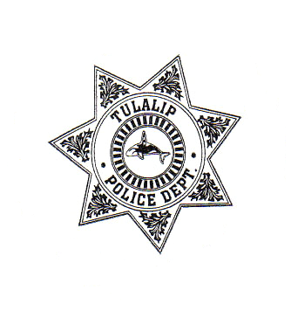

Office of Neighborhoods
Tulalip Office of Neighborhoods
In Partnership with
The Tulalip Police Department
The Tulalip Housing Authority
6729 Totem Beach Road
Tulalip, WA 98271
360-651-4361
360-651-4608

Action Plan

Non-Emergency Incidents

- Contact your Block Watch Captain.

- Contact neighbors who are affected by the problem and who might be able to monitor the problem.

- Contact your Tulalip Police Officer as soon as practical.

- Monitor the problem if possible.

- Try to find the person responsible or the source of the problem.

Example: Graffiti, disagreement with neighbors, garbage in the area, abandoned cars, speeding traffic, and information about your neighborhood in general.

Emergency Incidents

- Call 911 first.

- Contact the Block Watch Captain.

- Contact other neighbors who are able to monitor the problem.

- Monitor the problem if possible.

- BE A GOOD WITNESS. STAY OUT OF HARM’S WAY. If you MUST approach the location, approach in a group and leave as soon as possible. This may be dome to remove frightened person(s) from a residence. Call 911 if this is done. Video tape if appropriate.

- Observe details such as:
- Description of person(s), sex, race, hair color, clothing, height, weight, and name if possible.
- Description of vehicle(s), (CYMBAL) color, year, make, body type, and license plate number.
- Direction of travel, if it (person or vehicle) leaves the site.
- Descriptions of the location, physical address, cross streets. This helps the Tulalip Police Officer to safely approach the location.
- Note the use of any weapons, gun, knife, etc.
- Known past incidents at the location or with the person(s) involved.

Example: Disturbances, assaults, prowlers, theft, burglary, suspicious person(s), noise problems (barking dogs, music, party), reckless drivers, and medical/fire emergencies.

