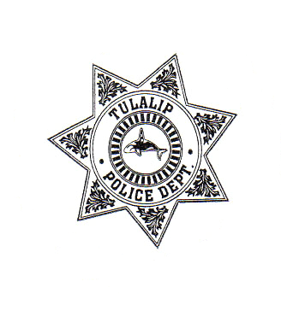

Office of Neighborhoods
Tulalip Office of Neighborhoods
In Partnership with
The Tulalip Police Department
The Tulalip Housing Authority
6729 Totem Beach Road
Tulalip, WA 98271
360-651-4361
360-651-4608

Tulalip Police Department Community Policing
Cooperative community effort is still society’s most effective tool in accomplishing objectives too large for the individual. As isolated individual may have little control over his/her environment, but in cooperation with others, can accomplish much. You and your neighbors can prevent crime within your community and make it a safer, more secure place to live. Even though today’s lifestyles sometimes make it difficult to be as neighborly as we’d like, being a good neighbor is one of the best ways to prevent crime. Neighbors can be your best protection when you band together to look out for each other’s interest.

What is Block Watch?
Block Watch is simply a program of neighbors watching over neighbor’s property. At all times when you are at home, be alert to what’s going on in your neighborhood. A Tulalip Police Officer patrolling your community may not recognize a stranger in your yard, but a neighbor would.

How Does Block Watch Work?
The program works through cooperation – NEIGHBORS WATCHING OUT FOR NEIGHBORS. Neighbors know who you are, and what type of car you own. They may be the first to notice a burglar at your window or door. Each neighbor can effectively watch those homes to each side, the front and back of his own home.
The Block Watch Program is not intended to form citizen crime watch patrol or vigilante groups. You are only asked to report the situation to the Tulalip Police Department and let them handle it. It is not a good idea to confront any suspicious person(s) or attempt arrest yourself; your safety could be in jeopardy.

Activities to Watch for

– Screams from anywhere
– Anyone removing valuable from home or vehicles
– Should of broken windows or shattered wood
– Persons going door to door
– Strange vehicles parked at your neighbor’s house
– Vehicles passing by numerous times, suspiciously parked or constantly traveling back alleys
– Anyone being forced into a car
– Beam from flashlight or light in a neighbor’s home
– Persons loitering around the neighborhood.

IF YOU SEE SOMETHING SUSPICIOUS…..Write down the description of any suspicious person(s). Get the make, model, color, and license numbers of strange vehicles. Call the Tulalip Police Department and members of your Block Watch Groups immediately. Don’t assume someone else has called……..CALL 911 IMMEDIATELY.

How to Report a Crime
Tulalip Police Department needs your help reporting crimes. Be alert wherever you are and learn to recognize crime. When you see or hear something that might indicate a criminal act is being committed, don’t hesitate to call the Tulalip Police Department.

When you are reporting a crime, stay calm and state the problem. Give the address where the emergency is occurring. Remember to give the full address and the nearest cross street.

It is important to be able to describe the offender to the Tulalip Police Officers after the offense has occurred. Tulalip Police Officers need to know the suspect’s race, sex, age, height, weight, build, complexion, hair color, eye color, clothing and miscellaneous identifying marks such as tattoos, scars, etc. Let the Tulalip Dispatcher control the conversation. Answer all the questions to ensure the best response.

