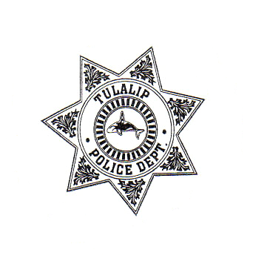

Office of Neighborhoods
Tulalip Office of Neighborhoods
In Partnership with
The Tulalip Police Department
The Tulalip Housing Authority
6729 Totem Beach Road
Tulalip, WA 98271
360-651-4361
360-651-4608

Volunteer Services Patrol Agreement

I have chosen to patrol my neighborhood as a member of my Neighborhood Block Watch Program in Coordination with the Tulalip Office of Neighborhoods and the Tulalip Police Department. I understand that I am only to watch for and report suspicious activity and record information about the activity. I accept responsibility for my own actions and will respect my patrol companions as to not act in any way that would reflect negatively or unnecessarily jeopardize their personal safety. I understand that I am a volunteer and not an employee of any one person or group. I understand that I may not hold responsible any individual or group for any injury that I may suffer while on patrol that may occur through no fault of my own or other.

I agree to abide by the following rules at all times:

- I will always be non-confrontational and practice being a good witness.
- When on patrol, I will not carry anything that resembles a weapon.
- I will not patrol under the influence of alcohol or drugs.
- I will follow the direction of and report all suspicious activity to the Volunteer Patrol Coordinator. In cases of emergency, I will immediately report to Tulalip Police Services at 360-651-4608, and then to the Volunteer Patrol Coordinator.
- I agree to carry all items provided by the Volunteer Patrol Coordinator with my person while on patrol. These items will aid in the safety of our patrols and will include such items as flashlights, identification, note pad and pencil, cell phone, etc.
- When using the citizen patrol vehicle, I will provide a copy of my valid driver’s license to be kept on file by the Volunteer Patrol Coordinator and the Chief of Police.

I understand the Chief of Police can amend these rules at any time and that I will be provided with a copy of changes that would directly affect my patrol.

Name of Volunteer: _________________________________________

Address: __________________________________________________

Phone: ___________________________________________________

Signature of Volunteer: ________________________________________

Signature of Coordinator:______________________________________

Signature of Chief of Police: ___________________________________

