Standard Operating Procedures
For Incident Response
TEMPLATE

Developed for Tribal Communities
By NW Tribal Emergency Mgmt. Council
March 2010

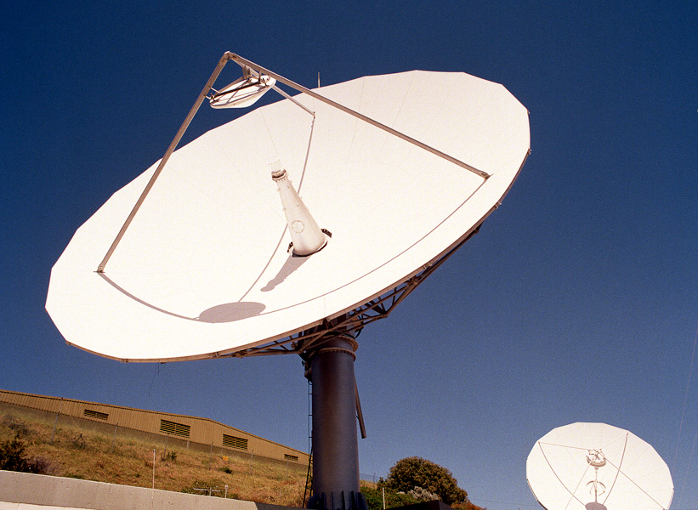
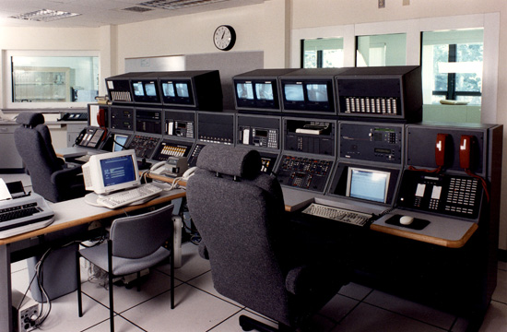
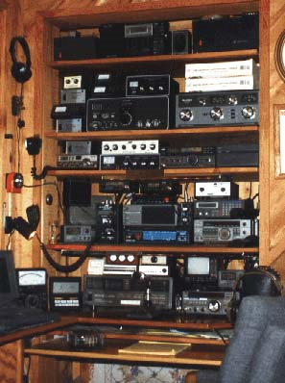


Section 1: Introduction 3
Section 2: Purpose 3
Section 3: Scope 3
Section 4: Communications Structure 3
Section 5: Channel Patching and Monitoring 4
Section 6: Activation, Transfer, and Discontinuation 5
Section 7: Separation of the interoperability channel due to interference 6
Section 8: Communications Alternatives 7
Section 9: Training Requirements 8
Section 10: Testing Requirements 8
Section 11: Responsibility 9

Appendix 1: Personnel with Interoperability Channel Capabilities 10
Appendix 2: The Military Phonetic Alphabet 11
Appendix 3: Communications Centers Contact Information 12
Appendix 4: Satellite Phone Numbers 13
Appendix 5: Training Guiding Principles 14

Section 1: Introduction
[Insert name of tribe here] public safety agencies recognize the need for interagency communication, interoperability, and cooperation. [Insert name of tribe here] police, fire response, and Emergency Medical Services (EMS) have well-established interoperability capabilities and mutual aid agreements in place. While these plans and agreements formally extend beyond jurisdictions, they tend to remain intra-discipline in practice. Today’s public safety realities highlight the need for agencies to work together to establish communications interoperability and mutual aid plans—not only across traditional jurisdictional boundaries—but across disciplines as well.

To remedy the lack of ability to communicate among disciplines, the [insert name of tribe here] public safety agencies, [insert agency names here], as well as the public service agencies, [insert agency names], have worked cooperatively to develop an intra-jurisdictional interoperability solution. This solution establishes dedicated radio channels with procedures that are accessible on communication equipment used by key public service officials, public safety officials, and public/private service executives.

Section 2: Purpose
The principal objective of the intra-jurisdictional interoperability channel is to provide key decision makers from various agencies a real-time means of direct voice communications. Not only will this enhance the efficiency of a multi-agency response, it will save lives by quickly disseminating critical information to participating emergency responder agencies at the scene of a significant incident anywhere in the tribe’s areas.

The purpose of this SOP is to delineate the authority, roles, and procedures for tribal agency supervisory personnel to use the intra-jurisdictional interoperability channel.

These personnel are outlined in Figure 2 (see page 6). This SOP also recognizes a number of interoperable communications alternatives to the intra-jurisdictional interoperability channel, which allow the [insert tribe name here] public safety and public service personnel to communicate during critical incidents.

Section 3: Scope
The scope of this SOP includes [insert name of tribe here] public safety agencies including [insert name of tribe here] police, fire, and EMS as well as [insert name of tribe here] public service agencies including [insert public service agency names here]. These agencies have worked cooperatively to develop the intra-jurisdictional interoperability channel and standard operating procedures, which will be used at the agency command level during critical incidents or at the discretion of the mayor. In the future, other agencies may enter into a Memorandum of Understanding (MOU) with the tribe for use of the channel and will agree to operate according to the procedures outlined in this document.

Section 4: Communications Structure

[Title]
____________

[Title]
__________

[Title]
_________

[Title]
________
[Title]
________

[Title]
_____________

[Title]
____________

[Title]
____________

[Title]
____________

[Title]
___________

[Title]
___________

[Title]
___________

[Title]

_______________

Section 5: Channel Patching and Monitoring

Patching
The intra-jurisdictional interoperability channel consists of a dedicated UHF radio channel patched to an 800 MHz talk group. This patched network permits users operating on either frequency band to communicate directly with other intra-jurisdictional interoperability channel users. This continuous patch alleviates the need to set up a patch during an actual incident. Should the UHF/800 patch need to be separated, the intra-jurisdictional interoperability channel would still serve as a valuable interoperability resource. While UHF users would lose the ability to communicate directly on the 800 frequency, they might still be able to communicate with others operating within their own frequency.

Monitoring
All agencies’ dispatch/radio communications centers will monitor the intra-jurisdictional interoperability channel. Once it is activated, all dispatch/radio communications centers will be required to monitor the channel on a priority basis until its use is discontinued.

Section 6: Activation, Transfer, and Discontinuation

Rules of Use

Plain Language
Plain language is to be used when communicating on the intra-jurisdictional interoperability channel. When necessary, the phonetic alphabet may be used to communicate over the channel. See Appendix 2 for an example of the military phonetic alphabet.

Incident Command System (ICS)
Each agency will use ICS as an operational guide at incidents where the intra-jurisdictional interoperability channel is activated.

Emergency Information Transmission
Once the intra-jurisdictional interoperability channel is activated, information that poses an imminent danger condition should be communicated between dispatch/radio communications centers (i.e., police dispatch center, fire alarm and/or EMS). The receiving dispatch/radio communications center is required to acknowledge receipt of the emergency information. Additionally, each agency is responsible for disseminating this information to its respective personnel.

In the case of an imminent danger condition where the intra-jurisdictional interoperability channel cannot be activated for reasons beyond operational control, agencies operating at the scene will be notified of the situation as quickly as possible.
Some options for this notification are to use a computer-aided dispatch (CAD) center, telephone, or emergency hotline.

Operational Procedure and Guidelines for Limited and Full Activation

Limited Activation
Limited activation is appropriate when an incident can be resolved by the resources of public safety or public service agencies. During these incidents, public safety or public service agencies can use the intra-jurisdictional interoperability channel.

Full Activation
Full activation is appropriate when an incident requires the activation of the Emergency Operations Center (EOC) as ordered by the mayor and/or the emergency management director. During a large-scale incident, previously defined procedures will be on the intra-jurisdictional interoperability channel until the EOC is fully staffed. Agency heads will be able to speak to each other for acquisition of resources. Once the EOC is fully staffed, the operations officer at the EOC will be the primary source for acquisition of resources. At this point, the intra-jurisdictional interoperability channel’s function will shift to unified command, incident mitigation, and personnel safety.

Radio Channel Activation Authority

Use of the intra-jurisdictional interoperability channel may be requested whenever an agency’s incident commander (IC), the highest-ranking officer of the controlling agency, determines the need to communicate directly with other agency representatives who have access to the channel. Each agency has the right to use the channel as necessary for public safety and availability of necessary resources. It is important to note that use of the channel is not intended to replace the establishment of an on-scene unified command post among responding agencies. The intra-jurisdictional interoperability channel is intended to assist communications until a command post can be established or to speak with an agency representative not yet on the scene.

Establishing and Transferring Lead Dispatch Radio Command Control

The IC, identifying the need for interoperable communications, will contact his/her respective dispatch/radio communications center (i.e., Council’s office, police dispatch center, fire alarm, and/or EMS). The IC will request that specific agencies switch their radio to the intra-jurisdictional interoperability channel. The dispatch/radio communications center of the agency that initiates use of the interoperability channel has the responsibility to notify all other required agencies by radio or telephone in accordance with the procedures outlined in this SOP. The dispatch/radio communications center will become the lead dispatch/radio communications center.
The designation of the lead dispatch/radio communications center may be changed as the lead agency requires or requests.

If the IC is transferred, the new IC will notify his/her respective dispatch/radio communications center by radio or telephone that he or she is the new IC for the agency. That dispatch/radio communications center will then become the lead dispatch/radio communications center of the intra-jurisdictional interoperability channel. Please refer to Appendix 3 for dispatch/radio communications center contact information.

Notification Process for Establishing Command Control

Each agency participating in the intra-jurisdictional interoperability channel will follow its own internal notification procedures for establishing command and control.

The Tribal Chair, police Chief, Fire/EMS Chief and Emergency
Management (EM) Director or their designees are authorized to activate the intra-jurisdictional interoperability channel.

Discontinuation of the Interoperability channel

At such a time that communication on the intra-jurisdictional interoperability channel is no longer required, the IC of the lead agency will notify his/her respective dispatch/ radio communications center to discontinue active use of the intra-jurisdictional interoperability channel, and normal monitoring will resume. The lead dispatch/radio communication center will notify all participating dispatch/radio communications centers that the intra-jurisdictional interoperability channel is no longer in use.

Section 7: Separation of the interoperability channel due to interference

In the event that there is intentional or unintentional interference with the intra-jurisdictional interoperability channel frequency, the dispatch/radio communications center and/or IC should notify the police department dispatch center duty supervisor by telephone. The duty supervisor will notify the director of communications to take down the patch; however, the responsibility for ensuring the patch is terminated belongs to the duty supervisor. When the patch between the UHF and 800 MHz trunked systems is separated, the radios will still work within their own frequency.

Section 8: Communications Alternatives

1. Telephone Conference Bridges
Telephone conference bridges permit direct communication among a number of users, assuming they have access to telephone services.

2. Cellular/Push-to-Talk Commercial Wireless Technology
Currently, most agencies use cellular/push-to-talk commercial wireless communications technology. In the event that the intra-jurisdictional interoperability channel is malfunctioning, this technology may be used to disseminate critical information to department heads and/or designees.

3. Computerized Emergency Notification System
The computerized emergency notification system will be programmed to contact specific individuals and agencies, depending on the nature of the incident. This includes appropriate media outlets, which could be used to inform the general public of situation updates, specific instructions, and/or emergency locations, if warranted.

4. Internet/E-mail
A lesson learned from September 11, 2001 was the power of the Internet and e-mail. While conventional communications outlets (i.e., wireless phones and land lines) were either damaged or overwhelmed, the Internet was up and provided an invaluable service to the general public. In the same way, the tribe’s online Emergency Operations Center (EOC) can be used as a means to pass information to various agencies that are involved in the event.

4.a. CASM
The Communication Assets Survey and Mapping (CASM) tool provides the ability for representatives of public safety agencies within an urban area or State to collect, store, and visualize data about agencies, communication assets, and how agencies use those assets.
The purpose of CASM is to:
- Provide a single repository for information about land mobile radio systems, other interoperability methods, and how they are used by public safety agencies within a state or urban area.
- Provide a method to display the data.
- Provide tools to analyze the data and visualize interoperability gaps in accordance with the Interoperability Continuum framework.

5. Satellite Phones
Satellite phones are assigned to the agency heads of the police department, fire department, EMS, EMA, and the mayor’s office for intercommunications if conventional phone lines become impaired. A cache of satellite phones will be stored at the EOC; and assigned for use by the EMA director and/or operations officer. The satellite phone numbers for agency heads are listed in Appendix 4.

6. Cache of Portable Radios on Various Bands
[Insert appropriate number here] caches of 800 MHz portable radios [insert total here] are available through [insert agency that is responsible for caches here]. These radios are able to provide a communications system on a local, regional, and statewide level in accord with existing mutual aid MOUs, resource-sharing agreements, and requests from other emergency responder agencies.

Because these radios work only on ITAC channels, their activation must be coordinated with the state police or the EMA prior to use.

7. Mobile Capabilities with Conventional Channels
Several command post and communications support vehicles are available through various public safety agencies.
These resources can be deployed to provide: a cache of spare UHF radio equipment, spare batteries, network video downlink capability, cross band patching, or base station repeaters. They can help support an extended operation or replace a damaged fixed repeater site.

8. Dispatch/Radio Communications Center to Dispatch/Radio Communications Center Messaging
Police, fire, and EMS share a common computer-aided dispatch (CAD) system capable of providing text messaging between users.

9. Runner System
In the unlikely event that the intra-jurisdictional interoperability channel and redundant back-up systems are all unavailable, the police department will arrange for a “runner system” in which designated personnel respond to the residence of department heads and other key agency representatives to make notifications and provide transportation as necessary.

Section 9: Training Requirements
Participating agencies will be responsible for ensuring that their personnel are familiar with this SOP and are properly trained in accordance with the guiding principles in Appendix 5.

Section 10: Testing Requirements
During standardized testing, the testing agency will communicate with participating public safety and public service agencies on the intra-jurisdictional interoperability channel.
There will be two different phases of radio testing:

1. Communications Center Testing
This weekly test of the intra-jurisdictional interoperability channel [insert day and time here] will be done between the public safety and public service dispatch/radio communication centers [insert appropriate agency names here]. The agency radio technician will monitor the UHF and 800 MHz trunked systems during testing.

2. Operational Testing
Each agency will decide when testing should take place. All agency heads or designated representatives with radios pre-set with the intra-jurisdictional interoperability channel will participate in this testing. During this test, the technical support will be checking the accuracy and performance of various sites.

Section 11: Responsibility
It will be the responsibility of agency heads to ensure that these SOPs are followed when necessary.
It will be the responsibility of all communication personnel to be familiar with and comply with these SOPs.

Appendix 1: Personnel with Interoperability Channel Capabilities

Title/Rank

Date of Last Revision_ _________________________________________________________
Name and Title_ ______________________________________________________________

Appendix 2: The Military Phonetic Alphabet
The phonetic alphabet may be used to communicate over the interoperability channel when necessary. Plain language should be used whenever possible.

The phonetic alphabet system, provided below, is recommended for those agencies lacking an operational alphabet system.

Alpha Bravo Charlie Delta Echo Foxtrot Golf Hotel India Juliet Kilo Lima Mike November Oscar Papa Quebec Romeo Sierra Tango Uniform Victor Whiskey X-ray Yankee Zulu

Appendix 3: Communications Centers Contact Information

Discipline | Communications Center/POC | Phone Number

Date of Last Revision_ _________________________________________________________
Name and Title_ ______________________________________________________________

Appendix 4: Satellite Phone Numbers

Satellite Phone Number | Agency | Department

Satellite Phone User Guide
[INSERT USER GUIDE HERE]

Appendix 5: Training Guiding Principles
At a minimum, each agency will give its own overview of the following:
• How the radio is set up
• How to select the right channel
• Proper terminology and radio etiquette
• Requirement that agencies using the channel must use plain English
• Requirement that agencies using the channel will use agency affiliation and title (Fire IC, EMS Staging Officer, etc.) in lieu of established agency call signs
• Who to notify in their agency if there is a radio problem
• Proper terminology and radio etiquette examples/Reference Guide
• When contact is established before a message is given
• Requirement that contact is initiated by holding the microphone three inches from the mouth, keying the radio, and waiting 1-2 seconds before speaking. The initiating party identifies his/her agency affiliation and title in addition to those of the person being called

Example:
“Fire District 5 to Public Works Highway Superintendent, have three front-end loaders report to Location 1 and 2 for removal of debris.”
The basic content of messages requiring an action is then repeated to the originator.

Example:
“Public Works Highway Superintendent to Fire District 5, sending three front-end loaders to Location 1 and 2 for removal of debris.”
If the person being called responds with “Who is calling the Public Works Highway Superintendent?,” then he/she did not understand who was calling. The initiating party would then repeat his/her agency affiliation and title in addition to those of the person being called to establish contact.

Example:
“Fire District 5 to Public Works Highway Superintendent”

Additional Information
• Resources and reference materials
• Training materials and their locations
• Industry guides and their locations
• Contact information

This Template developed by NWTEMC for local planning use.

This document based on:
“Writing Guide for Standard Operating Procedures”
which can be found at Safecom: http://www.safecomprogram.gov/NR/rdonlyres/2D396F0E-CE19-4DCB-A30A-35982721F5AA/0/SOP.pdf

also
WA CEMP, ESF 2, Communications http://www.emd.wa.gov/plans/documents/Planning_cemp_ESF2.doc
WA SCIP http://siec.wa.gov/plan/files/SCIP.pdf
Tactical Interoperable Communications Plan (TICP) Template

