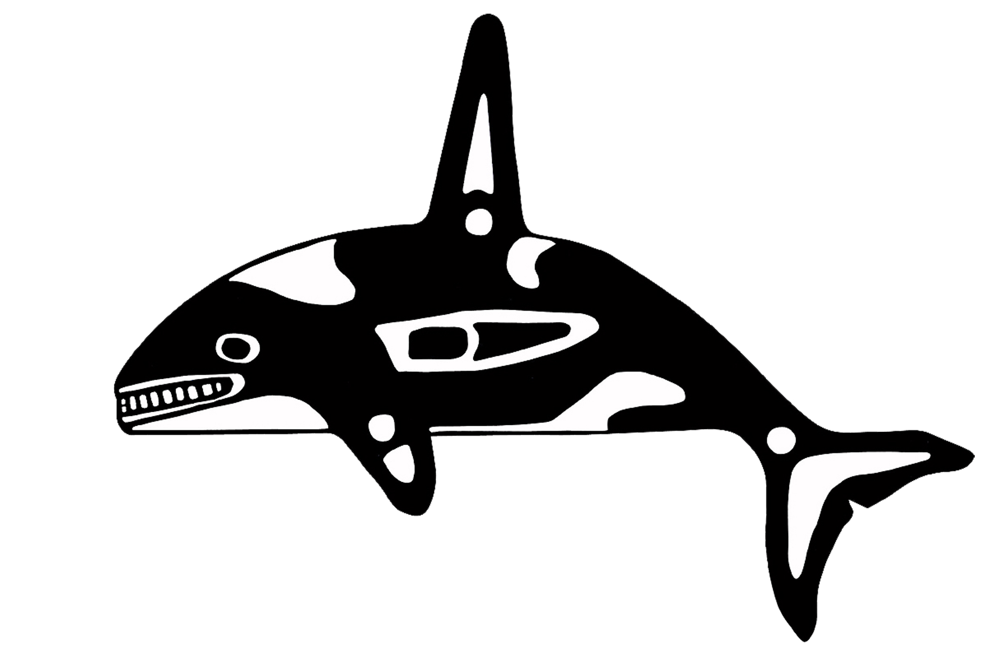

TULALIP TRIBES
PANDEMIC FLU RESPONSE PLAN

Short of a global conflict, a pandemic is the one scenario that will prove the greatest challenge to all aspects of our modern society. The complexity of the decisions required coupled with the global impact necessitates a well-defined plan. There are no right or wrong answers during the planning process. All possible problems and their corresponding solutions must be considered. This plan is not intended to be an end point to the planning process, but a starting point for working through the issues.

- INTRODUCTION

Influenza is an acute viral infection characterized by the sudden onset of fever, chills, headaches, muscle pains, severe prostration (weakness, exhaustion) and cough. It is mainly spread by the respiratory route through droplets of infectious respiratory secretions or by fine respiratory aerosols produced when an infected person talks, coughs, or sneezes. It may also be spread by hand/face contact after touching surfaces contaminated with infectious respiratory droplets. The incubation period is 1-3 days. People are contagious from the onset of symptoms through 4-5 days of illness. The acute symptoms last for about a week, although full recovery may take longer.

In most years, influenza occurs predominantly during the winter. Each year, millions of Americans get the flu. For most people, influenza is an unpleasant but not life-endangering illness. The very young, the elderly, and people with underlying diseases are particularly at risk of serious illness from influenza. Each year, an estimated 36,000 people die from influenza in the United States. Without interventions such as annual influenza immunization, the elderly and those of all ages in disease-based risk groups suffer significant morbidity and mortality even in a non-pandemic year.

Influenza A viruses are unique in their ability to cause sudden, pervasive illness with high rates of illness and death and considerable health care infrastructure disruption on a global scale. Three such pandemics have occurred in the past century--the Spanish (1918), Asian (1957), and Hong Kong (1968). The Spanish Flu pandemic of 1918 resulted in approximately 20 million deaths worldwide. Consistent features of pandemics include sudden increases in morbidity and mortality, with rapid spread around the world. There is a tendency for pandemics to recur in second and sometimes third waves. Not knowing which influenza virus strain is going to cause the next pandemic makes planning for it very challenging. The likely impact of a pandemic depends upon characteristics of the virus such as its infectivity, attack rates in different ages and the severity of disease it causes.

GOALS
The primary goal of this plan is to give local decision makers a clear and easy to read guide that defines roles, responsibilities and predetermined decision points that are likely to occur throughout the pandemic. In addition to being a guide to response, the plan should also serve as a lightning rod for the potentially politically charged and complicated questions that need to be asked and answered well before the onset of any pandemic. The Tulalip Tribes’ Pandemic Flu Response Plan will be coordinated with local, regional, and state partners.

The purpose of the plan is to:

- Define activities that the Tulalip Tribes and partner agencies may do before a pandemic. occurs to prepare for a pandemic flu response.
- Define the decision-making structure and coordinated response efforts among the Tulalip. Tribes and partner agencies of Snohomish County, and state and federal agencies.
- Define roles and responsibilities of the Tulalip Tribes and local response partners during a pandemic.
- Describe Public Health activities during a pandemic influenza event.

The objectives of the plan are to:

- Maintain a surveillance system for early illness detection.
- Rapidly assess the epidemiology of a new pandemic in order to plan response efforts.
- Assure implementation of disease control measures as appropriate for the stage of the pandemic.
- Limit morbidity and mortality due to infection with the pandemic strain.
- Provide timely, authoritative and up-to-date information for health care providers, the public and the media throughout the event.

The plan will assist the Tulalip Tribes and partner agencies in achieving the following goals:

- Minimize illnesses and deaths
- Maintain continuity of government and essential services
- Minimize social disruption
- Minimize economic losses

BASIC ASSUMPTIONS

Influenza pandemics have occurred at intervals from 11 to 42 years and could occur at any time.

A new virus may not follow the usual seasonal pattern of influenza, and may occur any time of year.

The next influenza pandemic may spread rapidly throughout the world.

Sustained human-to-human transmission anywhere in the world will be the triggering event to initiate a pandemic response and put this plan into action.

There are plenty of unknowns about the flu, what form it will take, its effect and how to treat it. Key is to remain flexible.

Minimal or non-existent help will be available from State and Federal partners initially.

Medical facilities will have little or no available space.

The pandemic may occur in waves lasting from 6 to 8 weeks over a period of 12 to 24 months.

During pandemic waves, 10 – 20% of workers will be off the job due to illness or caring for loved ones.

There will not be enough medication and vaccine supplies to treat all of the patients/residents initially.

Mortality rates for influenza victims may be extraordinarily high.

Hospitals and clinics will have to modify their normal operational structure and standards of care to respond to very high patient volumes.

Alternative care sites may need to be identified to triage and care for ill persons.

Shortages in certain supplies, such as gloves, masks, IV fluids and other critical items may develop due to interruptions in supply lines and production capacity.

The healthcare workforce may experience absenteeism of 25 to 40% at the peak due to illness in workers and family members, closure of schools and childcare centers and fear.

Demand for hospital beds and ventilators could increase by as much as 10-fold above normal.

Emergency Medical Services (EMS) and Urgent Care Medical Services will face extremely high demands.

Pandemic influenza response will consume all Public Health resources.

Timely, accurate and well-distributed public education will be the single most important key to an effective response before and during the pandemic.

This plan does not discuss all possible scenarios or complications that may be encountered during a scenario. Communication, common sense and quick thinking will still be of vital importance to a successful response.

SCOPE

The Influenza Response Plan focuses on the roles, responsibilities, and activities of The Tulalip Tribes Emergency Response Personnel. The plan also emphasizes responsibilities and actions of key community partners in an effort to emphasize coordination among the agencies during an event response. The community partner responsibilities and actions were identified through a joint planning group of Tulalip community partners. The Tulalip Tribes Emergency Management Council and community partners formed a joint planning group to discuss the issues around pandemic influenza and provide input to this plan. The Tulalip Tribes Emergency Management Council is comprised of representatives from sixty-five separate programs within the Tribal Government.

The Tulalip Tribes Response Personnel encourage all community partners and business leaders to incorporate planning and preparedness into their own emergency response plans.

This plan does not address response efforts that will be undertaken if avian influenza is identified in our bird or other animal population. State and federal agriculture agencies hold the primary responsibility for surveillance and response efforts in the animal population, although it is acknowledged that agricultural efforts interface with human disease surveillance and control efforts. It is also recognized that communication and collaboration with agriculture agencies will be an essential part of the Tulalip Tribes surveillance system. A Tulalip Tribes liaison will maintain contact with liaisons of the agriculture agencies to monitor animal surveillance data.

STAGES OF PANDEMIC
Below are several incremental guides to the stages of a pandemic, both at the global and local levels.

V. PHASES OF A PANDEMIC

The World Health Organization has developed a classification system for guiding response activities to an influenza pandemic. The phases are:

Pandemic Phase | Definition
Interpandemic Period (Phases 1 & 2) | - Phase 1 - no new influenza virus subtypes have been detected in humans. An influenza virus subtype that has caused human infection or disease may or may not be present in animals. If present in animals, the risk of human infection or disease is considered to be low.  - Phase 2 - No new influenza virus subtypes have been detected in humans. However, a circulating animal influenza virus subtype poses a substantial risk of human disease.
Pandemic Alert (Phases 3, 4, 5)  Current Phase as of 8/06: Phase 3 | - Phase 3 - Human infections with a new subtype, but no human-to-human spread, or at most rare instances of spread to a close contact.  - Phase 4 - Small clusters with limited human-to-human transmission but spread is highly localized, suggesting that the virus is not well adapted to humans.  - Phase 5 - Larger clusters but human-to-human spread still localized, suggesting that the virus is becoming increasingly better adapted to humans, but may not yet be fully transmissible (substantial pandemic risk).
Pandemic period (Phase 6) | - Phase 6 - Increased and sustained transmission in the general population.
Post-pandemic period (Return to Interpandemic period) | - A return to the interpandemic period (the expected levels of disease with a seasonal strain) follows, with continued need to maintain surveillance and regularly update planning. An intensive phase of recovery and evaluation may be required.

ACTION STEPS TO TAKE IN RESPONSE
Potential Action Step When to take Action

Mobilization Steps
Accumulate stockpile of flu medication Immediately
(if available). Accumulate stockpile of
N-95 masks. Initiate printing of simple
public education materials. Convene meeting
of the Pandemic Flu Taskforce.

Initiate aggressive public information At change of pandemic status to
Campaign: community meetings, media Phase 5: Large cluster(s), but
human-to human spread is still localized.

Pass out N-95 masks to first responders, After first confirmed cases of
medical staff and other essential employees, Pandemic flu in WA State.
casino employees, clinic employees
Open EOC

Issue Tulalip Tribes Emergency Proclamation When local resources are clearly taxed beyond their ability to respond, or when economic impact of outbreak negatively affects reservation.

Close Schools After first confirmed cases of
Pandemic flu in Snohomish Co.

Pass out N-95 masks to general residents After first confirmed case of
of county plus casino patrons flu in Snohomish Co.
.
Close all restaurants, stores, facilities, etc. After confirmed 50th case of flu in Snohomish Co.

Close all public gatherings After confirmed 50th case of
flu in Snohomish Co.

Close all non-essential government After confirmed 50th case of
business flu in Snohomish Co.

Demobilization Steps

Reopen all non-essential government After no new confirmed cases
business county-wide for 4 days.

Reopen all restaurants, stores, Tribal facilities, etc After no new confirmed cases
county-wide for 4 days.

Re-allow all public gatherings After no new confirmed cases
county-wide for 4 days.

Reopen Schools After no new confirmed cases
county-wide for 10 days.
Close EOC At confirmation of end of pandemic.

PRIORITIES FOR MEDICATION AND VACCINE DISTIBUTION

Priority 1
- Medical providers and staff
- Law enforcement essential staff
- Fire/EMS essential staff (if not already covered by Snohomish Co.)
- Emergency management staff
- Essential government staff including elected officials
- Elders, Family leaders
- Public Health essential staff
- Public works essential staff

Priority 2
- Essential staff of local utilities
- Families of priority 1 personnel
- Key general population residents as determined by Public Health Officer and/or TULALIP TRIBES Emergency Preparedness Official

Priority 3
- Families of priority 2 personnel
- High risk general population residents as determined by Public Health Officer and/or TULALIP TRIBES Emergency Preparedness Official

Priority 4
- General population.

ROLES AND RESPONSIBILITIES OF PRIMARY AGENCIES

Tulalip Public Health Officer – Indian Health Service
-Serve as incident commander (may designate alternate).

TULALIP TRIBES Health and Community Services – Sheryl Fryberg & Wally Paisano
-coordinate public information campaign with Tulalip Tribes PIO George White
-coordinate distribution of masks, medications and vaccines
-perform active epidemiological monitoring

Tulalip Police Dept.
-enforce all closures, bans on movement and quarantine orders
-provide site security for all vaccine or medication points of distribution and storage facilities

TULALIP TRIBES Emergency Management Department- Lynda Harvey
-open and staff Emergency Operation Center
-assist other agencies with all aspects of response
-coordinates issuing of emergency proclamation

Local Emergency Medical Services – Snohomish County Dist 15 and Marysville Fire
-ensure local capability to meet needs of general population during pandemic. Recognize that capabilities may be less than ideal
-establish clear protocols for staff

Local Clinics/Medical Providers – Tulalip Tribes Health Clinic
-ensure local capability to meet needs of general population during pandemic. Recognize that capabilities may be less than ideal
-establish clear protocols for staff

Elected Officials - TULALIP TRIBES
-fill leadership role in local community
-assist in coordinating recovery efforts post-epidemic

At Phase 6, The TULALIP TRIBES Emergency Management Director may ask that people stay at home with their families to decrease the chance of the infection spreading further throughout our community. This will be accomplished with Tribal Council approval.

